Week 25 Exam prac Exercises
SOST10142/20142 Applied Statistics for Social Scientists
2024-03-05

1. Sample means (unknown 𝜎) confidence interval

1.1 Weekly TV-watching hours
A random sample of Scottish youth data (n=100) shows that pupils’ (11-17 years of age) weekly TV watching hours is estimated as mean 11.64 hours; standard deviation 3.977. Based on a 5% significance level, what is the range of possible mean hours for all pupils across Scotland? (t-critical value for α = .05, two-tailed for df=99 is 1.984)

n = 100, Sample SD (S) = 3.977, CI = Point estimate ± margin of error = $\overline{x}$ ± t * SE = $\overline{x}$ ± t * $\frac{\text{SD}}{\sqrt{\text{n}}}$
CI = 11.64 ± 1.984* $\frac{\text{3.977}}{\sqrt{\text{100}}}$ = 11.64 ± 0.7890 = 10.85, 12.43
Between 10.85 hours and 12.43 hours
c(11.64 - 1.984 * (3.977 / sqrt(100)) ,
11.64 + 1.984 * (3.977 / sqrt(100)) )
[1] 10.85096 12.42904

# critical t for both 2.5th and 97.5th percentiles
qt(c(0.025, 0.975), df = 99)
[1] -1.984217 1.984217

2. Interpret the 95% confidence interval.
We are 95% confident that the actual mean weekly TV watching hours of all Scottotish pupils lie somewhere between 10.85 and 12.43 hours.

2. Sample proportions confidence interval

2.1 Feeling unsafe
1. A recent survey by Ipsos MORI involving a random sample of 1000 university students in the UK found that 40% have felt unsafe around the residential halls. Based on these data, calculate 95% confidence interval (Use α = .05).
$\hat{\text{p}}$ = .40, $\hat{\text{q}}$ = .60, n = 1000, CI = Point estimate ± margin of error = $\hat{\text{p}}$ ± 1.96 * $\sqrt{\frac{\hat{\text{p}}\hat{\text{q}}}{\text{n}}}$
CI = 0.40 ± 1.96 * $\sqrt{\frac{\text{0.4*0.6}}{\text{1000}}}$ = 0.40 ± 0.03036419 = 36.96%, 43.04%. In R,
c(0.40 - 1.96*(sqrt(0.40*0.60/1000)),
0.40 + 1.96*(sqrt(0.40*0.60/1000)) )
[1] 0.3696358 0.4303642

2. Interpret the 95% confidence interval.
We are 95% confident that the actual percentage of all UK university students have felt unsafe around the residential halls in recent years lies somewhere between 36.96% and 43.04%.

3. Sample proportions z-test

3.1 One sample proportions: supporting gay and lesbian rights

YouGov conducted a study using a random sample among 1751 individuals in the UK between 19 – 20 May 2022 revealed that 910 (52%) stated discrimination against transgender people is a major problem or a significant problem in Britain today. In 2012, about 50% of individuals in the UK recognised the discrimination against transgender people. At the 5% significance level, test if the percentage of UK residents who recognise the discrimination against transgender people has increased since 2012 (= more than 50% of UK residents are in support of transgender people’s rights in 2022).

H₀: p = 0.50 It is true that 50% of UK residents are in support of transgender people’s rights.
H_{a}: p > 0.50 It is true that greater than 50% of UK residents are in support of transgender people’s rights (right-tailed), α = 0.05.

We need to obtain the z-test statistic and compare it to the critical value (cut-off point).

z = $\frac{\text{Observed }\text{sample}\text{ proportion}\text{ - }\text{ Hypothesised }\text{population}\text{ proportion}}{\text{SE}\text{0}}$ = $\frac{\hat{\text{p}}\text{ - p}\text{0}}{\text{SE}\text{0}}$ = $\frac{\hat{\text{p}}\text{ - p}\text{0}}{\sqrt{\frac{\text{p}\text{0}\text{*}\text{q}\text{0}}{\text{n}}}}$
z = $\frac{\hat{\text{p}}\text{ - p}\text{0}}{\text{SE}\text{0}}=\frac{\text{0.52 - 0.50}}{\sqrt{\frac{\text{0.50*0.50}}{\text{1751}}}}$ = $\frac{\text{0.02}}{\text{0.01194887}}$ = 1.673798

The critical value of normal distrubtion for a one-tailed test is 1.645. As the test statistic falls in the rejection area (1.673798 > 1.645), we reject the null hypothesis. We conclude that at the 5% significance level, the data provide sufficient evidence to conclude that more than 50% of UK residents are in support of transgender people’s rights. This suggests that the data provide sufficient evidence to conclude that the percentage of UK residents in support of transgender people’s rights has increased since 2012.
# critical z for 95th percentile
qnorm(0.95)
[1] 1.644854
# p-value
pnorm(1.41, lower.tail=FALSE)
[1] 0.07926984
(Also a good example found in Johnson & Bhattacharyya 2011 p.334), poverty level.

3.2 Two sample proportions: supporting immigration by gender

A random sample of 30 females and 30 males in the UK collected by Ipsos MORI finds that 18 females and 14 males support immigration to the UK. Can we generalise that the UK women are more likely than the UK men to support immigration to the UK? Establish H₀ and H_{a} and perform a z-test using the 5% significance level.
H₀: p1 = p2 Women and men are equally likely to support immigration to the UK.
H_{a}: p1 > p2 Women are more likely than men to support immigration to the UK (right-tailed).
where p1 : the proportion of all UK women who support immigration
p2 : the proportion of all UK men who support immigration
${\hat{\text{p}}}_{\text{1}}$ = $\frac{\text{18}}{\text{30}}$ = 0.6, ${\hat{\text{q}}}_{\text{1}}$ = 0.4, ${\hat{\text{p}}}_{\text{2}}$= $\frac{\text{14}}{\text{30}}$ = 0.467, ${\hat{\text{q}}}_{\text{2}}$ = 1-0.467 = 0.533 and ${\hat{\text{p}}}_{\text{1}}\text{ - }{\hat{\text{p}}}_{\text{2}}$ = 0.133
Recall for one sample proportion’s CI = Point estimate ± margin of error = $\hat{\text{p}}$ ± 1.96 * $\sqrt{\frac{\hat{\text{p}}\hat{\text{q}}}{\text{n}}}$
(see section 2.1)
The formula for z-test statistic :
z = $\frac{{\hat{\text{p}}}_{\text{1}}\text{ -} {\hat{\text{p}}}_{\text{2}}}{\text{SE}}=\frac{{\hat{\text{p}}}_{\text{1}}\text{ -} {\hat{\text{p}}}_{\text{2}}}{\sqrt{\frac{{\hat{\text{p}}}_{\text{1}}{\hat{\text{q}}}_{\text{1}}}{\text{n1}}\text{ +} \frac{{\hat{\text{p}}}_{\text{2}}{\hat{\text{q}}}_{\text{2}}}{\text{n2}}}}$ = $\frac{\text{0.6} \text{-} \text{0.467}}{\sqrt{\frac{\text{0.6*0.4}}{\text{30}}+ \frac{\text{0.467*0.533}}{\text{30}}}}$ = $\frac{\text{0.133}}{\text{0.12766}}$ = 1.0418

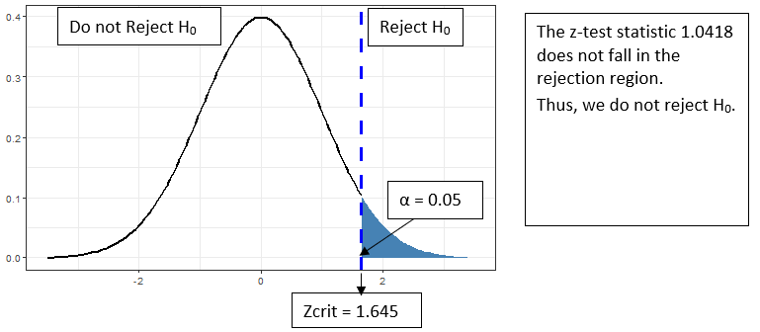

As the critical value of normal distrubtion for a one-tailed test is 1.645. As the test statistic (shown in a red solid line, 1.0418 < 1.645) does not fall in the rejection region, we fail to reject the null hypothesis. Consequently, at the 5% significance level, the data do not provide sufficient evidence to conclude that women are more likely to support immigration to the UK.
# p-value of z-test statistic, lower.tail=FALSE indicates a one-tailed test
pnorm(1.0418, lower.tail=FALSE)
[1] 0.1487522

4. Chi-square test

4.1 First-generation university students by gender

Using ESS data, we investigated the association between first-generation university students and gender. The data yield a cross-tabulation as below.
Write the hypothesis and describe the assumptions and conclude whether there is an association between gender and the first-generation university students status.
H₀: There is no association between first-generation university students and gender.
H_{a}: There is an association between first-generation university students and gender.

Observed |  |  |  |  | Expected
 | Gender |  |  |  |  | Gender
 | Men | Women | Total |  |  | Men | Women
First | 691 | 1245 | 1936 |  | First | = 817.143 | = 1118.86
Not first | 1259 | 1425 | 2684 |  | Not first | = 1132.857 | = 1551.14
 | 1950 | 2670 | 4620

χ² = $\frac{\sum{{\text{(O-E)}}^{\text{2}}}}{\text{E}}$
= 19.473 + 14.222 + 14.046 + 10.258 = 57.999
df = (r – 1)(c – 1) = (2-1) (2-1) = 1×1 = 1

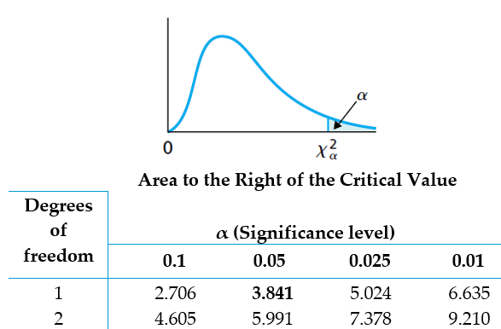

With 1 degree of freedom at the 5% significance level, the critical value of the χ² distribution is 3.84. The chi square test statistic, 57.99 is greater than 3.84 [χ² (1)= 57.99, p<0.001)]. Thus we reject the H_{o} and conclude that there is an association between first-generation university students and gender.

# Critical value of Chi-Square distribution, specify α=0.05
qchisq(p = 0.05, df = 1, lower.tail = FALSE)
﻿[1] 3.841459

# p-value for the Chi-Square test statistic
pchisq(q = 57.999, df = 1, lower.tail = FALSE)
[1] 0.00000000000002622511

Note: lower.tail: Default is TRUE. If TRUE, the probability to the
left of p or q in the χ² distribution is returned.

Odds ratio

5.1 Educational attainment and voting preference

 | Party voted for
 | Conservative | Other | Total
No degree | 387 | 245 | 632
Degree | 80 | 125 | 205
 | 467 | 370 | 837

Compare the odds that degree holding versus non-degree holding individuals vote conservative party in the UK.
$=\frac{\frac{\text{80}}{\text{ 125 }}}{\frac{\text{387}}{\text{ 245 }}}= \frac{ 80 * 245 }{ 387 * 125}$ = 0.4051

Note that odds ratio < 1. We need to take the inverse of 0.4051 for interpretation.
1/0.4051 = 2.468
The odds that degree holders vote conservative party are 2.5 times less than the odds for non-degree holders in the UK.
In other words, the odds that non-degree finishers vote conservative party are 2.5 times greater than the odds for degree holders in the UK.

Module selection by gender

 | Class
 | Sociology class | Other class | Total
Female | 32 | 77 | 109
Male | 17 | 74 | 91
 | 49 | 151 | 200

Compare the odds that female versus male students being in the Sociology class.

= $\frac{32 * 74 }{ 17 * 77}$ = 1.809
The odds for female students taking the Sociology class are 1.8 times greater than the odds for male students.

Online exam question topics:

- Calculate mean, median, mode,
- Calculate sum of squares, variance, standard deviation
- Calculate z-score
- Measurement scale(interval, nominal, ordinal)
- corresponding graph types for categorical, continuous measures
- Dependent, independent variables
- Normal distribution, t-distribution
- Standard error, confidence interval, precision,
- Hypothesis testing – t-test, proportion z-test (Practical 6)
- Chisquare test
- Odds ratio

https://yougov.co.uk/topics/society/articles-reports/2022/07/20/where-does-british-public-stand-transgender-rights

